Stage 2 Physics

Heating & Cooling Test

Name:

# **50 marks**

# **TIME**: 1 Hour

* A data sheet is supplied for student use

**NOTE:**

1. Calculations must show clear working with answers written in scientific notation stated to **three significant figures unless you are answering a question specifically asking you how many significant figures are technically required.**
2. Marks will be allocated for clear and logical setting out.
3. To help identify your answer, underline each answer.
4. State **assumptions** if working on open ended type questions.
5. Note that **NOT** all questions carry **equal** number of **marks**.
6. Answer **ALL** the questions.

Other constants required for this assessment:

|  |  |  |  |
| --- | --- | --- | --- |
|  | Specific Heat Capacity  (J K-1 kg-1) | Latent Heat of Fusion  (J kg-1) | Latent Heat of Vaporisation  (J kg-1) |
| Copper | 390 |  |  |
| Aluminium | 900 |  |  |
| Magnesium | 1050 |  |  |
| Wheat grain | 1509 |  |  |
| Plastic | 1671 |  |  |
| Lead | 128 | 2·5 × 104 | 8·6 × 106 |

1. A simple heat pack can be made by stuffing a bag with wheat grain and heating the bag in a microwave.  
   How much energy would a microwave need to supply to a wheat bag with a mass of 850 grams to increase the temperature by 28 °C? [2]
2. How much heat is absorbed by 0·155 kg of lead as it melts? [2]
3. Using the models of matter explain the following:
   1. Why solids have a fixed shape but liquids and gases do not: [1]

* 1. Why solids expand as they are heated: [1]

1. During its recent mission on Mars the NASA rover “Curiosity” discovered a new substance. Curiosity was able to isolate 1 gram of the substance and began heating it from the surface temperature of -55 °C. The graph below represents a summary of the data collected.

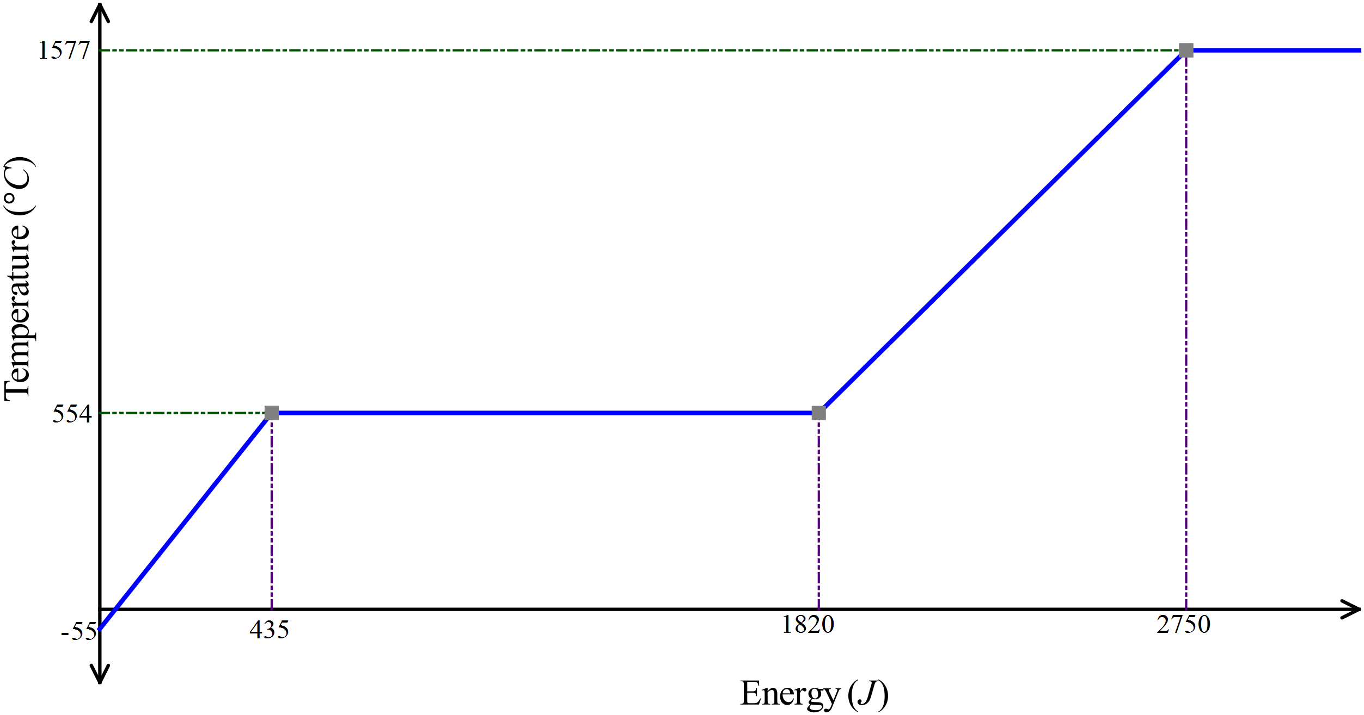

* 1. Explain why the temperature of the substance remains constant in the second part of the graph.

[3]

* 1. What is the melting point of this substance? [1]

* 1. What is the specific heat of the solid form of this substance? [3]
  2. What is the latent heat of fusion for this substance? [3]

1. Like many animals, Kangaroos do not have sweat glands. Kangaroos have been observed to repeatedly lick their forearms, coating an area of skin/fur close to blood vessels with saliva, which is essentially water.  
   Referring to heat energy concepts explain why this behavioural adaptation will lower the body temperature of the kangaroo. [3]

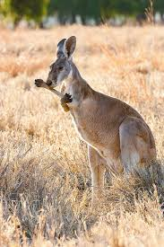

1. Consider a brick wall that has been exposed to the Sun for some time:
   1. Heat is transferred from the sun via only radiation. Explain why no other method of heat transfer is possible: [2]

* 1. The air over the wall seems to shimmer and shake as air currents rise from it. Explain what creates these air currents. [2]

* 1. You can feel the wall’s warmth some distance away. How does this heat get to you through the air? [1]

* 1. Which would you expect to be warmer after being exposed to the Sun for equal times – a white wall or a black wall? Explain. [3]

1. Distinguish between the following:
   1. Heating and Heat: [1]

* 1. Internal energy and temperature: [1]

1. A sample of magnesium is heated at a constant rate. The graph below shows how its temperature varies with time.

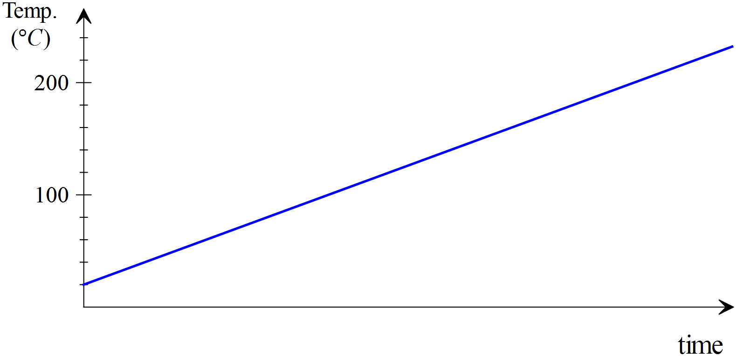

* 1. If an equal mass of copper at the same initial temperature is heated at the same rate, then the copper graph will be: **[select one of the following by ticking the corresponding box]** [1]
     1. Identical to the magnesium graph. □
     2. Steeper in slope. □
     3. Less steep in slope □
  2. Explain your answer to ‘a’ [2]

1. Which absorbs more heat? 15 grams of water or 150 grams of copper when they both experience a 5 °C increase in temperature. [3]

1. A 600 W camp-stove heats 0·75 kg of water in a 300 g aluminium kettle for 10 minutes from a starting temperature of 15 °C.
   1. How much energy is supplied to the kettle if the camp-stove is 75% efficient at transferring heat to the kettle? [2]
   2. Will the water in the kettle come to the boil? [2]
2. The safe bathing temperature for a new born baby is 36 °C. A mother of a new-born baby adds 1·5 litres of water with a temperature of 65 °C to a 2·3 kg plastic baby bath which is at room temperature (17 °C).
   1. What will the temperature of the water be when the water and bath reach thermal equilibrium?  
       [3]

* 1. How much cold water [@ 22 °C] needs to be added to make the temperature of the water safe for the new-born baby? (If you couldn’t get an answer for part (a), then use 50° as the initial temperature of the bath water). [3]

1. How much steam at 100 °C must be added to 40·0 g of ice at -6·00 °C in an insulated aluminium calorimeter of mass 53·0 g so that the ice melts and the final temperature of all the water is 5·5 °C.  
    [5]

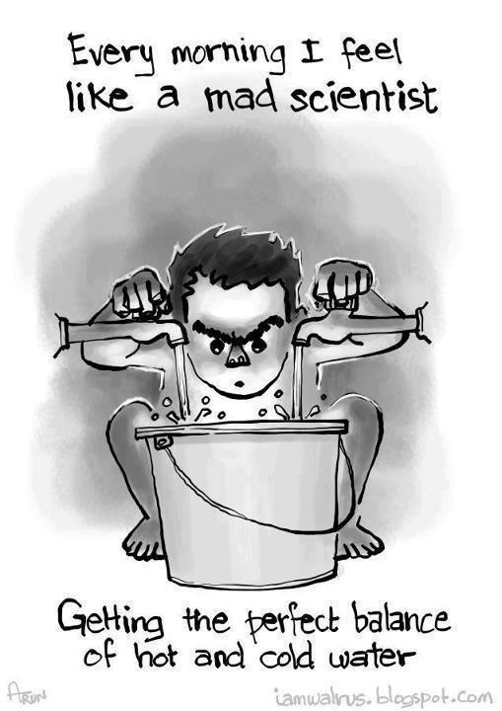

End of Test